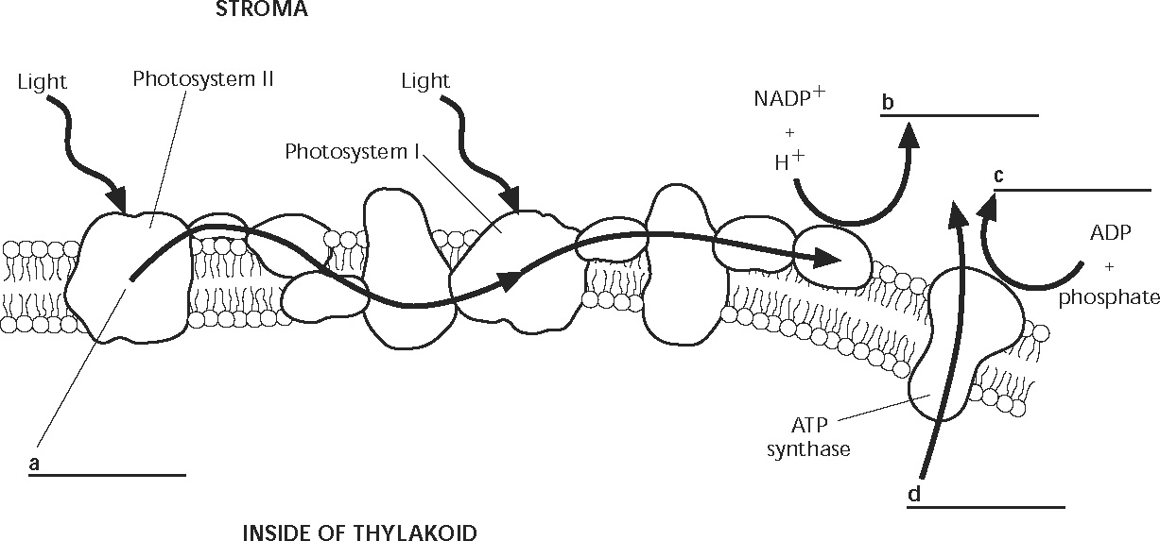

Path of sunlight for light dependent reactions
1. 2. 3. 4.
5. 6. 7. 8.

