Genetics with a Smile

Name _________________________________

Part A: Smiley Face Traits
- Obtain two coins from your teacher. Mark one coin with a ÒFÓ and the other with a ÒMÓ to represent each of the parents. The parents are heterozygous for all the Smiley Face traits.

- Flip the coins for parent for each trait. If the coin lands with heads up, it represents a dominant allele. A coin that lands tails up indicates a recessive allele. Record the result for each person by circling the correct letter. Use the results and the Smiley Face Traits page to determine the genotype and phenotype for each trait.

Trait |  | Female |  |  | Male |  |  | Genotype |  | Phenotype
Face Shape |  | C | c |  | C | c
Eye Shape |  | E | e |  | E | e
Hair Style |  | S | s |  | S | s
Smile |  | T | t |  | T | t
Ear Style |  | V | v |  | V | v
Nose Style |  | D | d |  | D | d
Face Color |  | Y | y |  | Y | y
Eye Color |  | B | b |  | B | b
Hair Length |  | L | l |  | L | l
Freckles |  | F | f |  | F | f
Nose Color |  | R | Y |  | R | Y
Ear Color |  | P | T |  | P | T

Part B: Is it a boy or girl?
To determine the sex of your smiley face, flip the coin for the male parent. Heads would represent X, while tails would be Y.

 | Female |  | Male |  | Genotype |  | Phenotype
Sex | X | X | Y

Part C: Create Your Smiley Face!
Use the Smiley Face Traits chart and your
results from Part A to create a sketch
of your smiley face in the box.
Don’t forget to give your smiley face
a name! You will also need to include
your name as parent and your class hour.

Genetics with a Smile

Smiley Face Traits

Face Shape |  | Nose Style
Circle (C) | Oval (c) | Down (D) |  |  | Up (d)
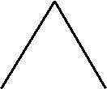
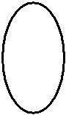
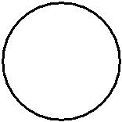

Eye Shape |  |  |  |  |  | Face Color | Eye Color
Star (E) |  |  |  | Blast (e) |  | Yellow (Y) | Blue (B)
 |  |  |  |  |  | Green (y) | Red (b)
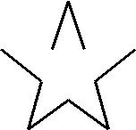
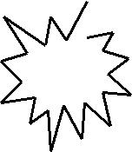

Hair Style |  |  |  |  |  |  |  |  |  |  |  |  |  |  |  |  |  |  |  |  |  |  |  |  |  |  |  |  |  |  |  |  |  |  |  |  |  |  |  |  |  |  |  |  |  |  |  |  |  |  |  |  |  |  |  |  | Hair Length | Freckles
Straight (S) |  |  |  |  |  |  |  |  |  |  |  |  | Curly (s) |  |  |  |  |  |  |  |  |  |  |  |  |  |  |  |  |  |  |  |  |  |  |  |  |  |  |  |  |  |  |  |  |  |  |  |  |  |  |  |  |  |  |  | Long (L) | Present (F)
Short (l) |  |  |  |  |  |  |  |  |  |  |  |  |  |  |  |  |  |  |  |  |  |  |  |  |  |  |  |  |  |  |  |  |  |  |  |  |  |  |  |  |  |  |  |  |  |  |  |  |  |  |  |  |  |  |  |  |  | Absent (f)
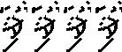

Smile |  |  |  |  |  |  |  |  |  |  |  |  |  | Nose Color | Ear Color
Thick (T) |  |  |  |  |  |  |  |  | Thin (t) |  |  |  |  | Red (RR) | Hot Pink (PP)
 |  |  |  |  |  |  |  |  |  |  |  |  |  | Orange (RY) | Purple (PT)
 |  |  |  |  |  |  |  |  |  |  |  |  |  | Yellow (YY) | Teal (TT)

Ear Style |  |  |  |  |  |  | Sex
Curved (V) |  |  |  | Pointed (v) |  |  | To determine the sex, the flip the coin for
 |  |  |  |  |  |  | the male parent. Heads equals X and tails
 |  |  |  |  |  |  | equals Y.
 |  |  |  |  |  |  | XX - Female - Add pink bow in hair
 |  |  |  |  |  |  | XY - Male - Add blue bow in hair

