Name Class Date
S E C T I O N 11 - 2 R E V I E W

G ENE E XPRESSION AND D EVELOPMENT

VOCABULARY REVIEW Distinguish between the terms in each of the following pairs of terms.

- cell differentiation, morphogenesis

- benign tumor, malignant tumor

- sarcoma, lymphoma

- oncogene, tumor-suppressor gene

MULTIPLE CHOICE Write the correct letter in the blank.

- The expression of different genes in different cells of a multicellular organism

  - contributes to the development of form in an organism.

  - causes the uncontrolled proliferation of cells.

  - is caused by the transfer of cells from one organism to another.

  - results from mutations that destroy normal gene functioning.

- Homeoboxes are

 | a. | found only in prokaryotes. |  | c. | mutations that can have devastating
 | b. found only in Drosophila. |  |  |  | consequences on development.
 |  |  |  | d. DNA sequences that regulate patterns
 |  |  |  |  | of development.
3. | The major distinguishing characteristic of cancer is
 | a. | uncontrolled cell division. |  | c. | metastasis.
 | b. rapid cell division. |  |  | d. tumor formation.
4. | Ninety percent of all lung cancers are caused by
 | a. asbestos. |  | b. cigarette tobacco. | c. X rays. |  | d. ultraviolet light.
5. | A gene whose normal function is to prevent uncontrolled cell division is
 | a. | an oncogene. |  | c. | a homeotic gene.
 | b. | a cancer gene. |  | d. | a tumor-suppressor gene.

Modern Biology Study Guide 57

Name Class Date

SHORT ANSWER Answer the questions in the space provided.

- How do homeotic genes regulate development in Drosophila?

- What factors influence whether a person will develop cancer?

- How can viruses induce cancer?

- How are introns and exons used in gene expression?

- Critical Thinking Most medicines used in cancer chemotherapy work by inhibiting cell division. Knowing this, explain why cancer patients who receive chemotherapy often experience a loss of

body hair.

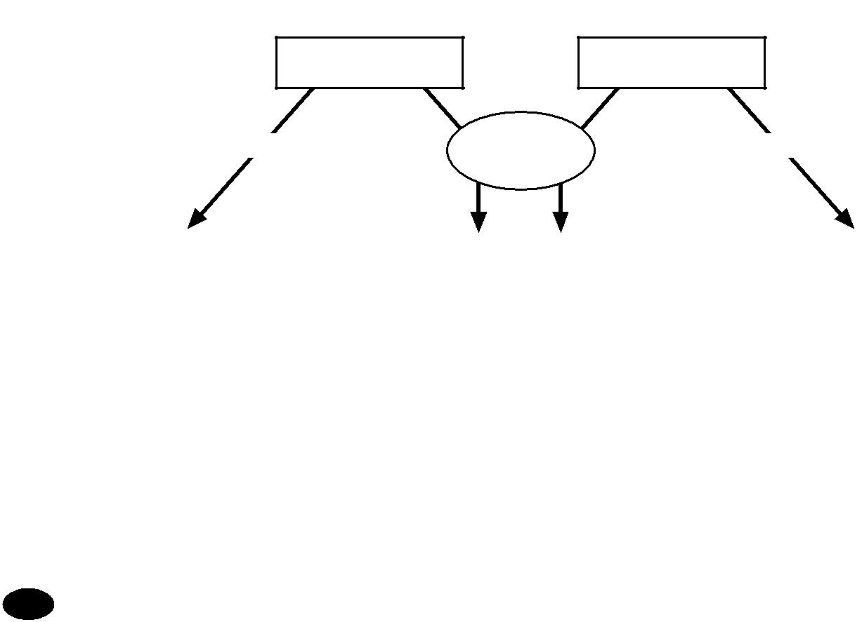
STRUCTURES AND FUNCTIONS Complete the flowchart below by filling in the three boxes at the bottom.

Tumor-suppressor
Proto-oncogenes
genes

Normal | Mutations | Normal

 | Effect: |  |  |  | Effect: |  |  |  | Effect:

