EOC practice quiz 7
- A diagram of a cell is shown below.
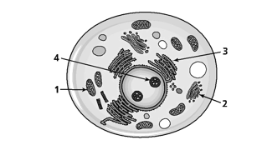

Proteins are synthesized in which numbered organelle?
- 1 c. 3
- 2 d. 4

- Which best describes how enzymes function in the body?
  - Enzymes are converted into products by the reactions they catalyze
  - Enzymes lower the activation energy of reactions
  - One enzyme can catalyze many different reactions
  - An enzyme is used once and then destroyed by the cell

- Generic drugs are copies that are the same as brand-name drugs in dosage, safety, strength, quality, and performance. Many people prefer generic drugs because they cost much less than their brand-name counterparts. Which best explains why pharmaceutical companies are able to sell generic drugs at a much lower cost than the brand-name drugs? (inquiry, technology, and engineering- connects to scientific method)
  - Generic drugs do not have the initial costs of production and advertising
  - Generic drugs do not have the approval of a government agency
  - Generic drugs do not have to be tested on humans
  - Generic drugs do not have to be packaged in childproof containers

- A student performed an investigation of the relationship between heart rate and blood pressure. The data collected is shown in the table below.
The student concluded the resting heart rate affects the resting blood pressure. Which statement supports the student’s conclusion? (inquiry, technology, and engineering- connects to scientific method)
Test Subject | Age | Gender | Resting Heart Rate (beats/min) | Resting Blood Pressure (mmHg)
Q | 15 | M | 70 | 115/80
R | 32 | M | 70 | 115/80
S | 15 | F | 76 | 115/80
T | 32 | F | 76 | 152/98

  - Subjects Q and S have the same resting blood pressure
  - Subjects Q and R are different ages
  - Subjects R and T have different resting blood pressure
  - Subjects S and T are the same gender
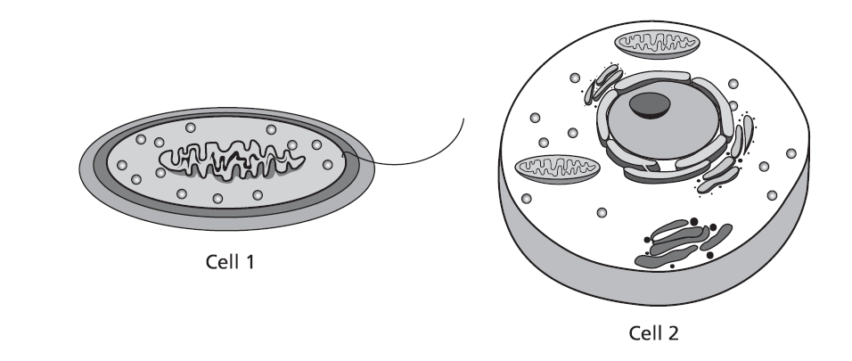
- Two cells are shown in the diagram above.
Which statement correctly identifies the cells?
  - Cell 1 is prokaryotic; cell 2 is eukaryotic
  - Cell 1 is eukaryotic; cell 2 is prokaryotic
  - Both cells are prokaryotic
  - Both cells are eukaryotic

- An ecologist performed a study to determine how the rate of photosynthetic activity in a lake changed from month to month. The results of the study are shown in the graph below.
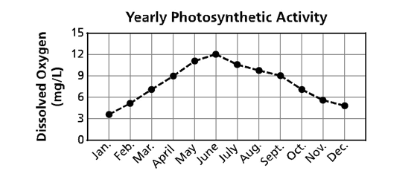
- Which conclusion is best supported by the evidence?
- Photosynthetic organisms were dormant during the months of April through August
- The rate of photosynthesis increased from June through December
- The rate of photosynthesis was greatest during the months of May through July
- Photosynthetic organisms experienced die-off during the months of January through June

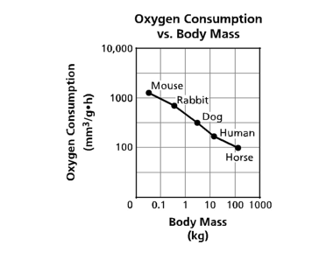

- The graph represents the relationship between an organism’s oxygen consumption and body mass. Which statement is supported by the information shown in the graph?
  - The oxygen consumption of an organism is one- half its body mass
  - The oxygen consumption of an organism is not related to its body mass
  - As the body mass of an organism increases, oxygen consumption decreases
  - As the body mass of an organism decreases, oxygen consumption decreases

