Name Class Date
S E C T I O N 11 - 1 R E V I E W

C ONTROL OF G ENE E XPRESSION

VOCABULARY REVIEW Explain the relationship between the terms in each of the following pairs of terms.

- regulator gene, repressor protein

- operator, repression

- inducer, activation

- transcription factor, enhancer

MULTIPLE CHOICE Write the correct letter in the blank.

- A gene is expressed when it is

  - present in the genome of an individual.

  - prevented from interacting with RNA polymerase.

  - transcribed into mRNA and that mRNA is translated into protein.

  - duplicated during the replication of DNA.

- In the lac operon of E. coli, lactose functions as

a. a promoter. |  | b. an operator. | c. a repressor protein d. an inducer.
3. In eukaryotic cells, transcription occurs
a. | on parts of the DNA that are uncoiled. |  | c. | only on exons.
b. | only on introns. |  | d. | on all parts of the DNA.

- Unlike gene expression in prokaryotes, gene expression in eukaryotes

  - cannot be regulated before transcription has occurred.

  - can be regulated after transcription has occurred.

  - does not involve promoters.

  - involves the transcription of groups of genes called operons.

- Enhancers

  - code for proteins called inducers. c. are found only in prokaryotic genomes.

b. must be located close to the genes d. facilitate transcription by binding to

they activate. transcription factors.

Modern Biology Study Guide 55

Name Class Date

SHORT ANSWER Answer the questions in the space provided.

- What is an operon, and in what type of organism are operons found?

- Describe what occurs during activation of the lac operon.

- Describe what occurs during repression of the lac operon.

- Critical Thinking How does the absence of a nuclear envelope in prokaryotes prevent prokaryotes from controlling gene expression by modifying RNA after transcription?

STRUCTURES AND FUNCTIONS Use the figure to answer the following questions.

- The diagram below represents the lac operon in the presence of lactose. Label each part of the diagram in the space provided.

b
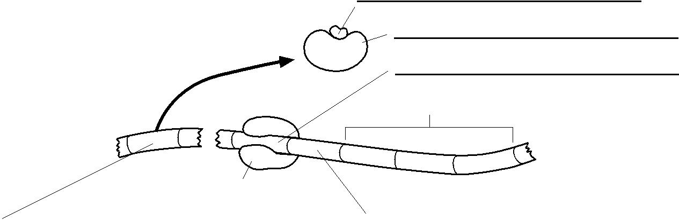
c

d

Structural genes

RNA polymerase

e
a

- If the regulator gene were deleted, how would this affect expression of the structural genes? Explain your answer.

- Is transcription of the structural genes activated or repressed under the conditions shown above? Explain your answer.

56 Section 11-1 Review

