Ch 19
1. Because individuals in a population usually tend to produce more than one offspring,
a. populations tend to increase in size.
b. populations remain stable in size.
c. individuals tend to die quickly.
d. the number of individuals declines rapidly.
2. Which of the following does not represent a population?
a. all the robins in Austin, Texas
b. all the grass frogs in the pond of Central Park in New York City
c. all the birds in Chicago, Illinois
d. all the elk in Yosemite National Park
3. Demographic studies of populations must take into consideration
a. population size.
b. population density.
c. population dispersion.
d. All of the above
4. If a population is composed of equal numbers of people of pre-reproductive, reproductive, and post-reproductive age, what will most likely happen to the size of the population?
a. It will remain stable.
b. It will experience no growth for a time and then increase rapidly.
c. It will decrease steadily.
d. It will experience no growth for a time and then decrease rapidly.
5. A population of organisms grows
a. with no natural restrictions except the availability of food.
b. when the birth rate exceeds the death rate.
c. only in the absence of predators or natural diseases.
d. All of the above
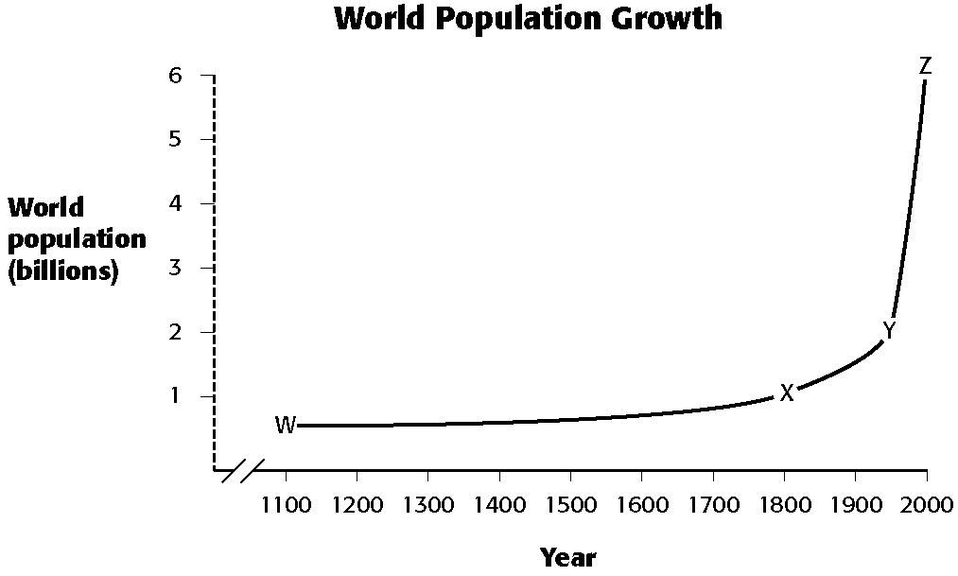
6. Refer to the illustration above. Which time period shows the highest rate of growth of the population?
a. period W–X c. period X–Y
b. period W–Y d. period Y–Z
7. Refer to the illustration above. Which of the following contributed to the change in world population during the 1900s that is shown in the graph?
a. better sanitation
b. improved health care
c. agricultural improvements
d. All of the above
8. Refer to the illustration above. Which point on the graph indicates the approximate world population in the year 1950?
a. W c. Y
b. X d. Z
9. Refer to the illustration above. The American Revolution began in 1776. According to the graph, what was the approximate world population at that time?
a. 500 thousand c. 1 billion
b. 1 million d. 2 billion
10. All of the following are problems arising from inbreeding except
a. reduction of a population’s genetic diversity.
b. increased genetic diversity within a population.
c. increased chance of homozygous recessive alleles for disease occurring.
d. reduction of a population’s ability to adapt to environmental changes.

