Name:
Cell Transport
- List and describe the five mechanisms of cell transport.

- Which mechanisms require energy to work?

- List the types of molecules each mechanism transports (general description).

- List two examples of each molecule that is transported for each mechanism (specific name).

- List the four factors of diffusion rate.

- What is the difference between diffusion and facilitated diffusion?

- Explain the difference between peripheral and integral proteins.

- Explain the difference between the three types of tonicity.

- What is the difference between plasmolysis and cytolysis-what is happening and to which cell?

- Define endocytosis, exocytosis, phagocytosis, and pinocytosis?

- List four other names for the cell membrane.

- Draw and label the parts of the cell membrane- phobic/philic and polar/nonpolar and integral/peripheral proteins.

- Draw the chart we discussed in class.

- A jellyfish is placed into a freshwater lake. Describe the type of solution the jellyfish is in and the movement of water based on this new environment.

- Define selectively permeable.

- Compare and contrast active and passive transport.

- Explain what polarity has to do with permeability.

A student put together the experimental setup shown below. The selectively permeable membrane is permeable to both types of solute molecules shown.

- Use figure 5-1 to answer the following question: Do you expect the distribution of solutes on each side of the membrane to change over time? Explain your answer.

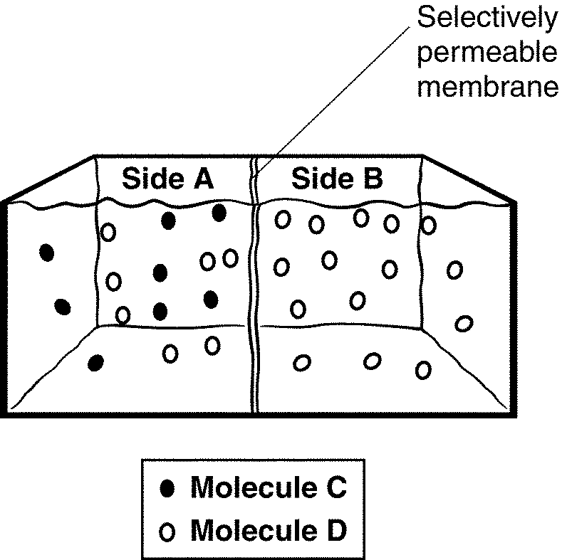
- Once equilibrium is reached in the apparatus shown in Figure 5-1, will the molecules continue to move? Explain your answer

