Bio EOC practice quiz 9
- In the pedigree below, how is this trait inherited?
  - Autosomal recessive
  - Autosomal dominant
  - Sex-linked recessive
  - Sex-linked dominant
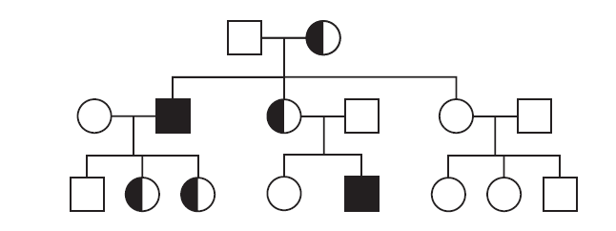

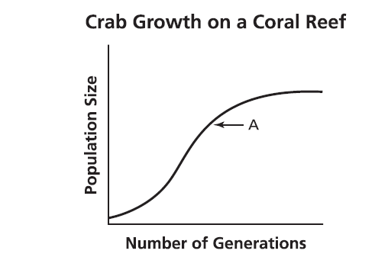

- Which statement best explains what is happening at point A?
  - Population growth decreases as individual crabs get older
  - The population is stabilizing as it approaches carrying capacity
  - Destruction of habitat is causing a decline in the population of the crabs
  - The introduction of a new predator is causing a decline in population growth of the crabs
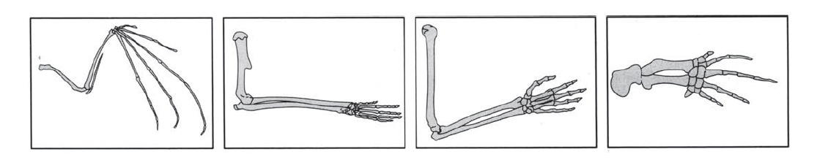
- The four species illustrated most likely have similar limb structures because they all
  - Share a common ancestor
  - Use their limbs for the same functions
  - Occupy the same level in a food pyramid
  - Adapted to the same environmental conditions
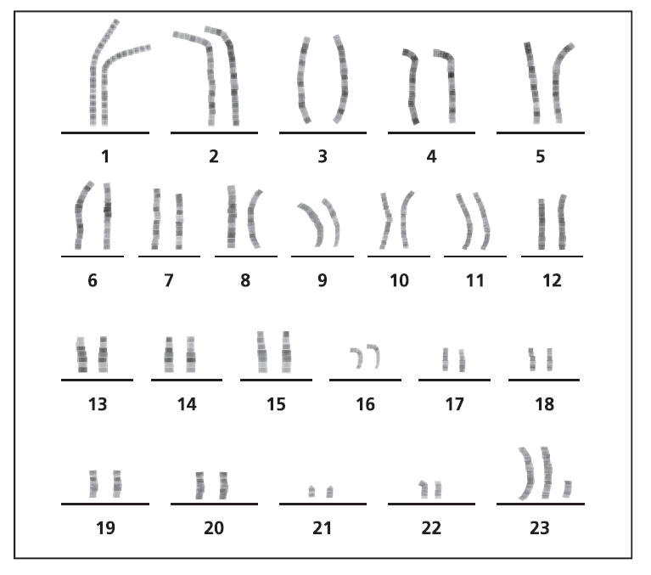
- In the karyotype above, which set of chromosomes represents a mutation?
  - 2
  - 11
  - 16
  - 23
- In the karyotype above, which process went wrong?
  - Cell growth c. respiration
  - Cell division d. photosynthesis
- The diagram showing the evolution of eight bird species is shown below. The differences in the species are most likely a result of
  - The length of mating season
  - The population size
  - Color of feathers
  - Available food sources
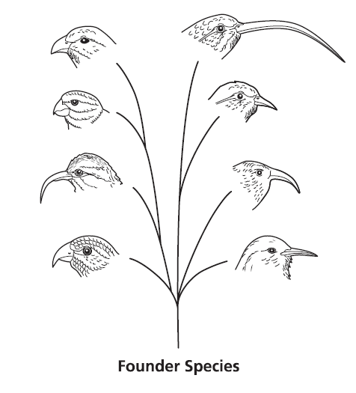

- A flock of one species of bird arrives on a group of sparsely populated islands. With little or no competition, different species of birds evolved from the original species. Each species is adapted to a different available niche. This is an example of
  - Divergent evolution
  - Convergent evolution
  - Dynamic equilibrium
  - Graduated equilibrium

