Bio EOC practice quiz 8 review
- Which best explains why a bacterial cell is classified as a prokaryote?
  - The presence of a nucleus
  - The absence of a nucleus
  - The presence of a cell wall
  - The absence of a cell wall
- In certain species of roses, white roses and red roses are incompletely dominant to each other. When a red rose and a white rose are crossed, a pink rose is produced. What is the probability of producing a white rose when a red rose is crossed with a pink rose?
  - 100%
  - 75%
  - 25%
  - 0%
- Which best describes how enzymes function in the body?
  - Enzymes are converted into products by the reactions they catalyze
  - Enzymes lower the activation energy of reactions
  - One enzyme can catalyze many different reactions
  - An enzyme is used once and then destroyed by the cell
- A student notices that the lettuce in a salad wilts soon after salt is added. Wilting most likely occurs because the lettuce cells
  - Swell when exposed to salt
  - Absorb the extra salt
  - Release water in the presence of salt
  - Lose oxygen when in contact with salt

- In active transport, carrier proteins
  - Move substance across the cell membrane without the use of ATP
  - Move from low concentration to high concentration by diffusion
  - Move small molecules through the cell membrane by osmosis
  - Move substance from a low concentration to high concentration through the use of energy
- Some microorganisms, such as yeast, produce energy in oxygen-free environments through the process of
  - Mitosis
  - Photosynthesis
  - Aerobic respiration
  - Anaerobic respiration
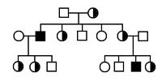
- According to the pedigree, what is the mode of inheritance for this disorder?
- Nonsex-linked dominant trait
- Nonsex-linked recessive trait
- Sex-linked trait carried on the Y chromosome
- Sex-linked trait carried on the X chromosome
- The main components of cell membranes are
  - Lipids
  - Proteins
  - Nucleic acids
  - Carbohydrates
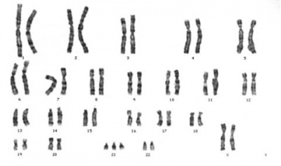
- In the human karyotype above, how many autosomes are present?
  - 22 c. 44
  - 23 d. 45
- Generic drugs are copies that are the same as brand-name drugs in dosage, safety, strength, quality, and performance. Many people prefer generic drugs because they cost much less than their brand-name counterparts. Which best explains why pharmaceutical companies are able to sell generic drugs at a much lower cost than the brand-name drugs? (inquiry, technology, and engineering- connects to scientific method)
  - Generic drugs do not have the initial costs of production and advertising
  - Generic drugs do not have the approval of a government agency
  - Generic drugs do not have to be tested on humans
  - Generic drugs do not have to be packaged in childproof containers

Answers
- B
- D
- B
- C
- D
- D
- D
- A
- D
- A

