Bio EOC practice quiz 6
- During the process of protein synthesis, a section of the DNA molecule is copied into which other molecule?
  - Nucleic acid c. messenger RNA
  - Cytoplasmic DNA d. transfer RNA
- A single sensory neuron cell extends from a person’s large toe to an area adjacent to the spinal canal of the central nervous system. Which process is responsible for the length of this cell?
  - Cell reproduction c. cell growth
  - Cell division d. cell diffusion
- The enzyme catalase is involved in the breakdown of hydrogen peroxide into water and oxygen. During this reaction, the catalase
  - Is unchanged c. is used up
  - Is changed into a product d. is formed into a new enzyme
- A human karyotype is shown in the diagram below. Which set of chromosomes represents a mutation?
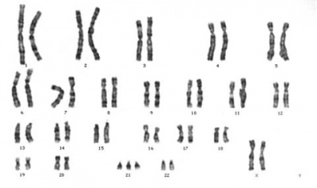
  - 1 c. 21
  - 12 d. X
- In the human karyotype above, how many autosomes are present?
  - 22 c. 44
  - 23 d. 45
- In the human karyotype above, which cellular process went wrong?
  - Photosynthesis c. cell division
  - Respiration d. protein synthesis

- In the human karyotype above, which mutation is most correct?
  - Gene inversion
  - Nondisjunction
  - Chromosomal deletion
  - Point mutation of a base

