BIO BW 2-13
- What do each of the following do: autosomes and sex chromosomes?
Autosomes- everything else or normal proteins
Sex chromosomes- gender
- In humans, ____________ creates 2 cells with _____ chromosomes.
  - Mitosis, 23 c. meiosis, 23
  - Mitosis, 46 d. meiosis, 46
2-14
- Define bioethics.
The rules/principles that says whether something is good or bad
- Which best describes how enzymes function in the body?
  - Enzymes are converted into products by the reactions they catalyze
  - Enzymes lower the activation energy of reactions
  - One enzyme can catalyze many different reactions
  - An enzyme is used once and then destroyed by the cell

2-15 2-16
- Who came up with binomial nomenclature?
Carl Linnaeus
- Which of the following is a nucleotide? Letter C
  - 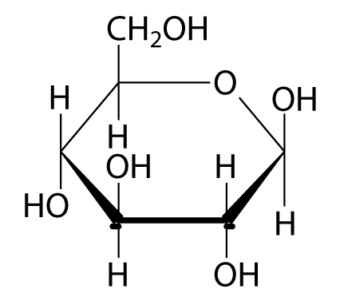

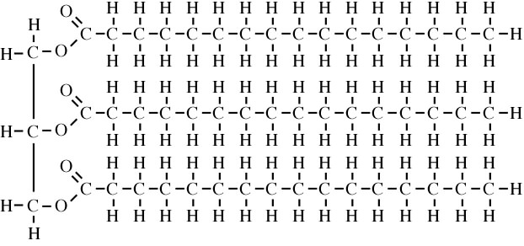

  - 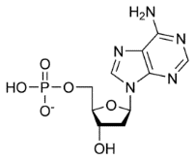

  - 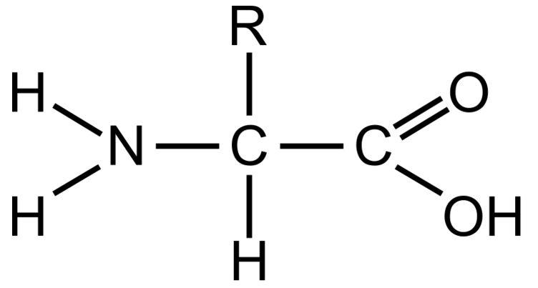

2-17
- Give one example of evolution in your lifetimes (hint: think about medicine). Antibiotic resistance
- Which of the following would turn purple in a test? Letter D

